

# 

# **KPI Prediction Tool: A Look Into The Future**

# 

# **Project Plan**

## **Economics 599/611**

## **Department of Economics**

## **University of Calgary**

# **Partners**

| **Name** | **Organization** |
| --- | --- |
| Ady Gray | Critical Mass |
| Gunpreet Singh | Critical Mass |
| Kimberley McDonough | Critical Mass |
| Dan Lewis | Critical Mass |

# **Team Information**

The Critical Mass team, sometimes referred to as ‘Team 4’, consists of five talented and hardworking individuals. “Looks like we have some smart people” were the words used by Gunpreet Singh, Marketing Science Lead at Critical Mass after meeting with Team 4. Our team, blessed with a variety of different academic backgrounds, instantly felt motivated by the Critical Mass project and selected it as our first choice. We were intrigued by the challenges this project presented and felt that our combined skill sets were perfect for creating the tool that the partner is looking for. Our team members along with their roles and responsibilities are listed below.

| **Name** | **Role** | **Responsibilities** |
| --- | --- | --- |
| Feyre Gezahegn | Report Lead | * Responsible for communicating with Critical Mass * Converts information obtained from data into readable language * Ensures the objective, process, and results of the project are clearly communicated |
| Wes Warman | Project Lead | * Work together with each Lead to ensure project flows * Ensure deadlines are going to be met and targets are reached |
| Muhammad Usman Khan | Engineering Lead | * Responsible for the creation and design of a GUI * Assist in the creation of the Model and the machine learning algorithm |
| Saul Chirinos | Data Lead | * Analyze, identify, and interpret patterns and trends in the data * Assist Modeling Lead with developing and tuning the forecasting algorithm * Assign data tasks to other team members such as data cleaning and exploratory data analysis. |
| Yutong Liu | Modeling Lead | * Doing the model construction, including the discussion of the model selection, feature engineering method and validation method. * Leading on aspects of comparing the different model performance to generate a more robust outcome. |

# **Project Objective**

The KPI project will work with Critical Mass, formally known as CM, to build a predictive tool which will forecast ‘Key Performance Indicators’ for new creatives as they launch. Each performance indicator is linked to a specific funnel and the funnel is divided into three parts. First, the upper funnel, consumers are ‘aware’, that is to say, they engage with the company. Second, the mid funnel, consumers ‘consider’ the company by exploring products by browsing the company website. Lastly, the low funnel, the ‘conversion’ phase, consumers purchase products from the company.

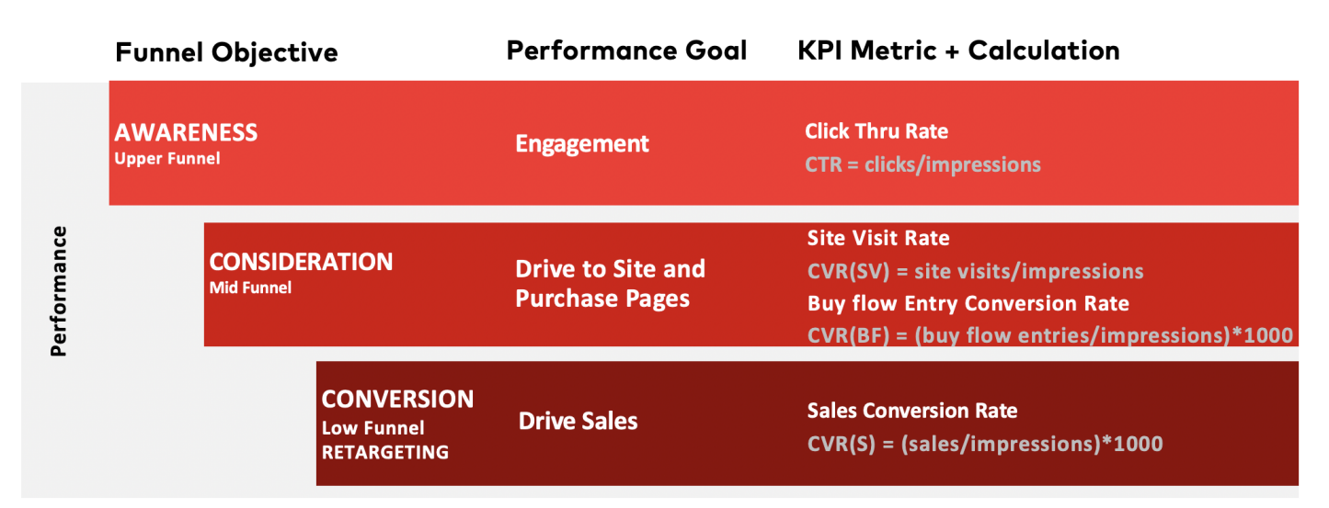

The task is divided into four main parts. First, start by data wrangling and transforming the given dataset to make it usable for our models. Secondly, an analysis will be conducted to determine correlation between the predictor and target variables. Third, build a predictive model to forecast funnel specific performance by the levels. Lastly, data visualization, allows usable tools and user interface to plug different inputs and visualize corresponding KPI.

# **How the project creates value for the organization**

The importance of forecasting KPIs for a given creative will allow CM to see how and where resources should be allocated to maximize efficiency and performance of a creative. The project will output the average expected (funnel specific) KPI, develop a performance trend line for the creative life cycle, and provide CM a user-friendly graphical user interface in which different inputs can be utilized to visualize corresponding KPIs. Additionally, the project will identify the most important features for KPI prediction, optimize the number of creatives per funnel and publisher, and identify the impact of the number of creatives in the market on performance. Once the project is completed, CM will have further ability to make effective and impactful business decisions through data science.

# **How the organization defines success**

With respect to the KPI prediction, Critical Mass considers the model a success in three respects: accuracy, improvement, and learning. One, since KPI forecasting is more accurate in comparison to price forecasting the project will be considered a success if it has a 55% or more accuracy to the true value.[1] Hence, the project yields higher value for CM as the relationship between the predictor and target variables improves. Two, if our KPI prediction tool can improve CM’s existing simple model by 10%, the model will be considered a success. Lastly, the KPI prediction can be considered a success by contributing to the existing or new primary and secondary learning outcomes, which further feeds into CM’s motto: measure, optimize, and adjust.

# **Prototype Description**

Our plan for the prototype model will include several features CM has provided to predict KPI performance. Our raw data consists of 13,271 creatives and 18 features along with weekly data for spending, number of impressions, click through rate (CTR), site visit conversion rate (CVRSV), buy flow conversion rate (CVRBF), and sales conversion rate (CVRS).

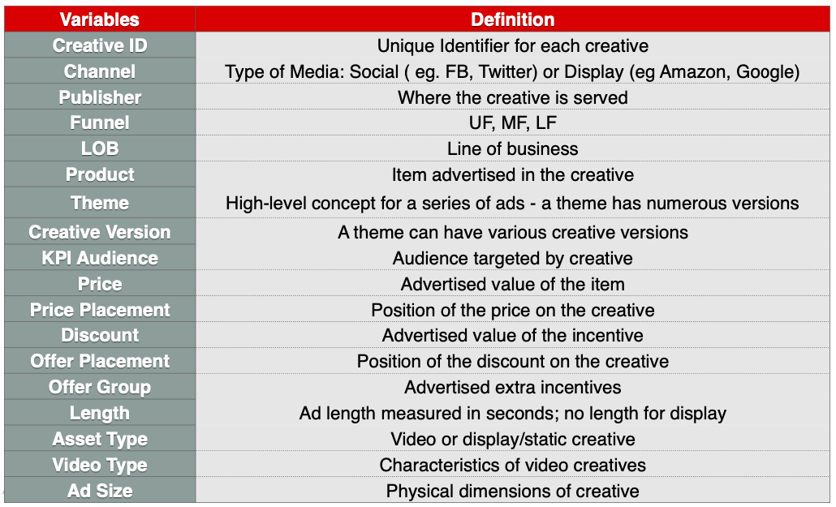

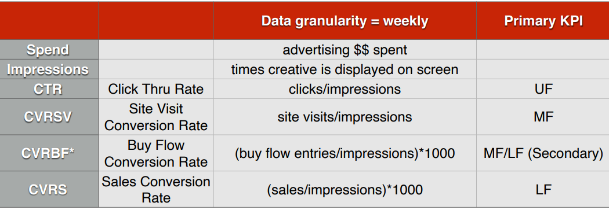

As for our algorithm design, we have not finalized our decision on a model. Before we select a model we need to think critically about the business problem and perform exploratory data analysis. Doing so will give us a better direction in deciding which models are viable and which ones are not. It is always best practice, however, to begin with a benchmark model, such as linear regression, due to its simplicity in interpretation. From there we can attempt to model more advanced algorithms. Once our final model is tuned and ready for production, we will connect it with Tableau. Due to Tableau’s scalability and visually appealing visualizations, relative to their competitors, we think it is a great platform to host our interface design and visualize our model outputs for CM. Additionally, since CM prefers Tableau as the graphical user interface, our data product should integrate smoothly into their system. The user interface will allow an employee of CM to plug in different values for each feature and in return display the forecasted funnel specific KPI along with a performance trend line for the creative.

# **Prototype Testing**

In this project, we are concerned about the model's performance hence, we will need to hypertune the model. Machine learning model testing has a few positive aspects: it requires people to assess the quality of the data rather than merely the model, and it requires you to go through several rounds changing the hyper parameters to achieve the best results. It is essential to test the prediction model in the following three major perspectives.

The first is the pre-training model testing for the machine learning algorithm, including the data input validation and function unit testing. In other words, we need to prepare all the data and functions to make sure the testing is successful. The second is the post-training model testing, including evaluating the model performance in the testing set or doing the cross-validation. Moreover, some evaluation metrics will also be utilized to generate a comprehensive model performance and accuracy summary. Finally, we will do model comparison to ensure our model will have at least a significant level of improvement in terms of the original model prediction.

# **Milestones and Deliverables**

| **Project Steps** | **Tasks AND Deliverables** | **Deadline** |
| --- | --- | --- |
| 1) Project Partner meeting | 1. Learn about the project partner (CM), their objective, and inquire about the project in detail. 2. Attain the data needed to work on the project from CM. | Jan. 20th      Jan. 24th |
| **2) Project Proposal** | 1. Constructing the Project Plan: Determine team roles, make a Gantt chart, and fill in information up to Prototype Description 2. *Completing the Project Plan*: Have a completed detailed project plan (edited) with the prototype description and testing. 3. Project Plan Agreement: Talk with CM and have the document signed. 4. Create a PPT Presentation: Start working on the PPT to present to class and project partners. 5. **Project Proposal**: Complete and submit the Project Proposal. | Jan. 29th      Feb. 3rd      Feb. 6-8th      Feb. 7th    **Feb. 6-8th** |
| 3) Understanding Data | 1. Data Wrangling: Work on Data wrangling and start brainstorming what the model will look like (e.g., specification) 2. *Data Cleaning I:* Understand and clean the data [Data Wrangling] and making it usable for the project. 3. *Data Analysis: Analyze data in plain language (use Tableau, Python, Stata e.t.c..)* | Feb. 12th  Feb. 15th      Feb. 17th |
| **4) Progress Report 1** | 1. Write Progress Report 1: Begin writing the progress report (max. dedicate 2 classes to get finish) | **Feb. 28-Mar. 10th** |
| 5) Scrubbing Data | 1. *Data Cleaning II:* further clean CM's data.      1. *Data Preparation*: Prepare and convert data to be used on various software and feature engineering. | Mar. 12th    Mar. 14th |
| 6) Forecasting Model | 1. Explore three forecasting approaches 2. Develop Forecasting Model 1 3. Develop Forecasting Model 2 4. Develop Forecasting Model 3 | Mar 14th    Mar 18th    Mar 18th    Mar 18th |
| 7) Model Evaluation | 1. Test and select an accurate model 2. Other types of Analysis | Mar 19th    Mar 19th |
| 8) User Testing (User-Guide & GUI) | 1. Create a user-guide for CM 2. Develop a GUI 3. Test the product with CM | Mar. 19th    Mar. 26th    Mar. 26th |
| **9) Progress Report 2** | 1. Write Progress Report 2: Begin writing the progress report (max. dedicate 3 classes to get finish) | **Mar. 22-31st** |
| 10) Project Deployment | 1. Modify the product based on feedback.      1. Complete the product extension      1. **Report and Presentation:** Get CM's feed on Final report + video for company to review.      1. **Submit the final product + user-guide to CM** | Apr. 4th  Apr. 4th    April 11th      Apr 14th-29th |

# **Post-Prototype Extension**

Following the completion of the prototype, the main objective will be to make an intuitive User Interface. The UI should consist of a few basic features: a method to accept new datasets in the form of csv files, a way to explore the visualized data (zooming in to different parts of the graph, finding key points along the graph, etc) and possibly a way to share the results. Once these conditions are met and an optimal User Interface is created, the next objective will be to revisit the algorithm and to explore ways of improving its efficiency and possibly explore other algorithms that incorporate variables that were not previously considered. For instance, suppose that the spending wasn’t seen as a relevant variable in the first algorithm, after a viable prototype is created, the spending can be re-examined to see its influence and the algorithm can be re-adapted to incorporate it.

1. Although it is considered difficult to achieve a KPI forecast of 80-90% accuracy, 55% accuracy is considered to be the average success rate. <https://neuravest.net/forecasting-kpi-using-ml-and-big-data-for-investment/>